**Java Mini-Project**

TOPIC:

ELECTRICITY BILLING SYSTEM

Group Members:

Angela Scaria (22122009)

Saristha Saha (22122044)

Kaustav Paul (22122026)

EXPLANATION OF THE APPLICATION

Electricity billing systems are an essential component of managing and calculating electricity consumption for residential, commercial, and industrial customers. These systems are responsible for accurately measuring the amount of electricity consumed by each customer, generating bills based on the consumption data, and providing a transparent and efficient process for billing and payment.

Our project consists of a GUI made using Java Swing. It lets User perform multiple operations like:-

1- User can Create his Personal login for security purposes.

2- User can Add customers and Calculate their Electricity Bill.

3- User can Pay Electricity Bills.

4- User can Generate Bill.

About Project:

This Java application was created using Visual Studio Code. It contains 9 different classes which works together to create a better user experience.

->Splash Screen class

->Login Screen class

->Main System class

->Add Customer class

->Pay Bill class

->Generate Bill class

->Show Details class

->Last Bill class

->Connection Setup class (JDBC - MySQL)

Database (MySQL):

Here, we have used the ltbill database.

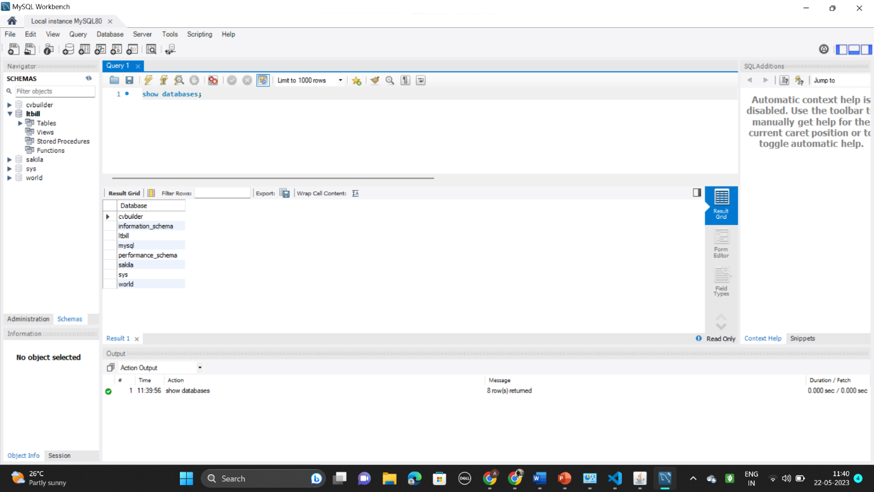

Database for this Electricity Billing System contains 4 Tables:

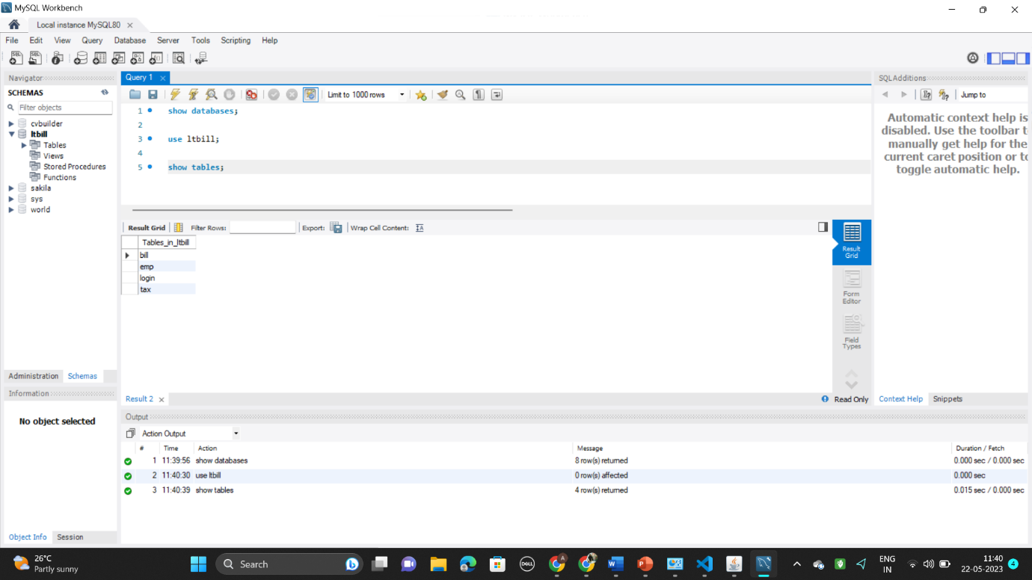

* login Table (userName,password)

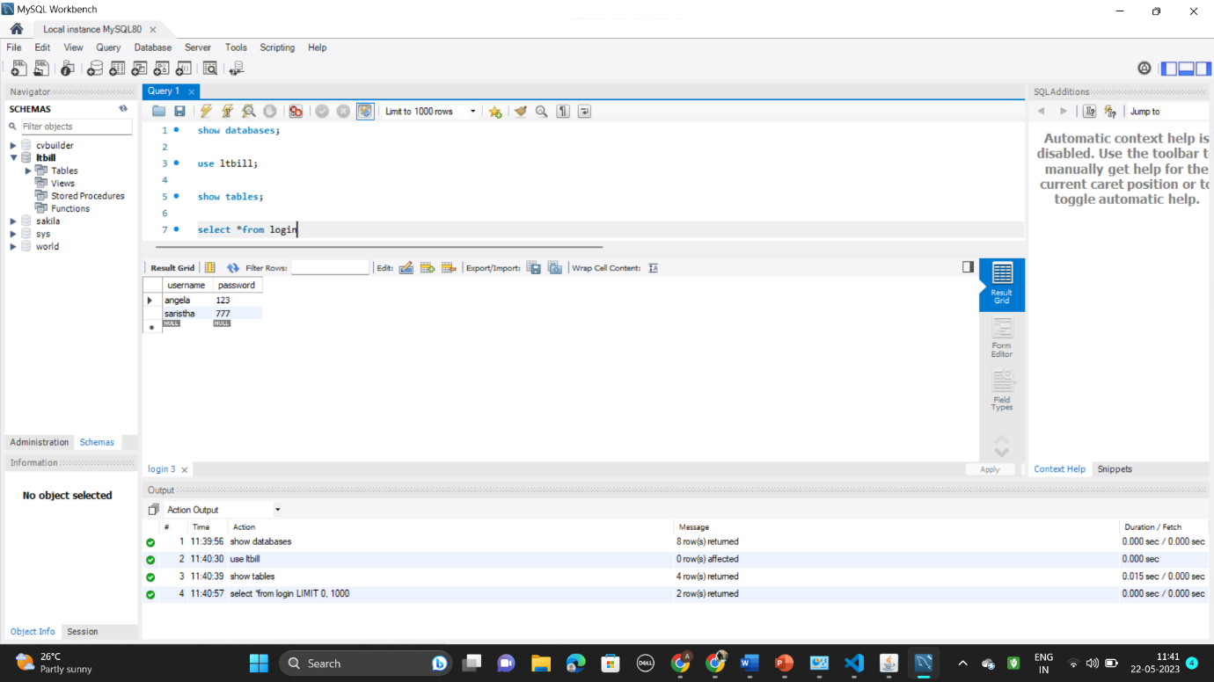

* bill Table(meter_number,units,month,amount)

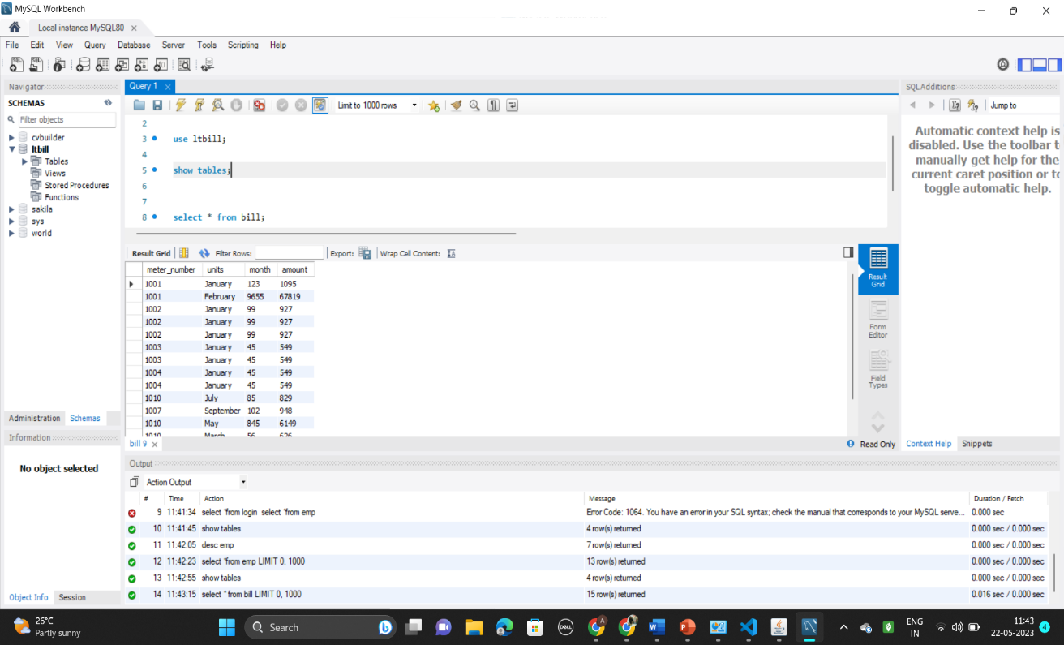

* emp Table(name, meter_number, address, state, city, email, phone)

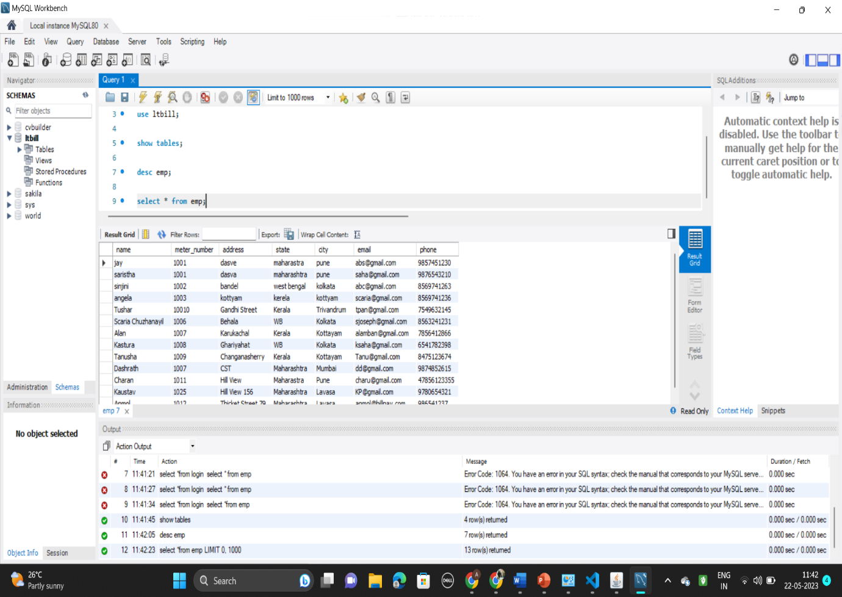

* taxTable(meter_location,meter_type,phase_code,bill_type,days,meter_rent,mcn_rent,service_rent,gst)

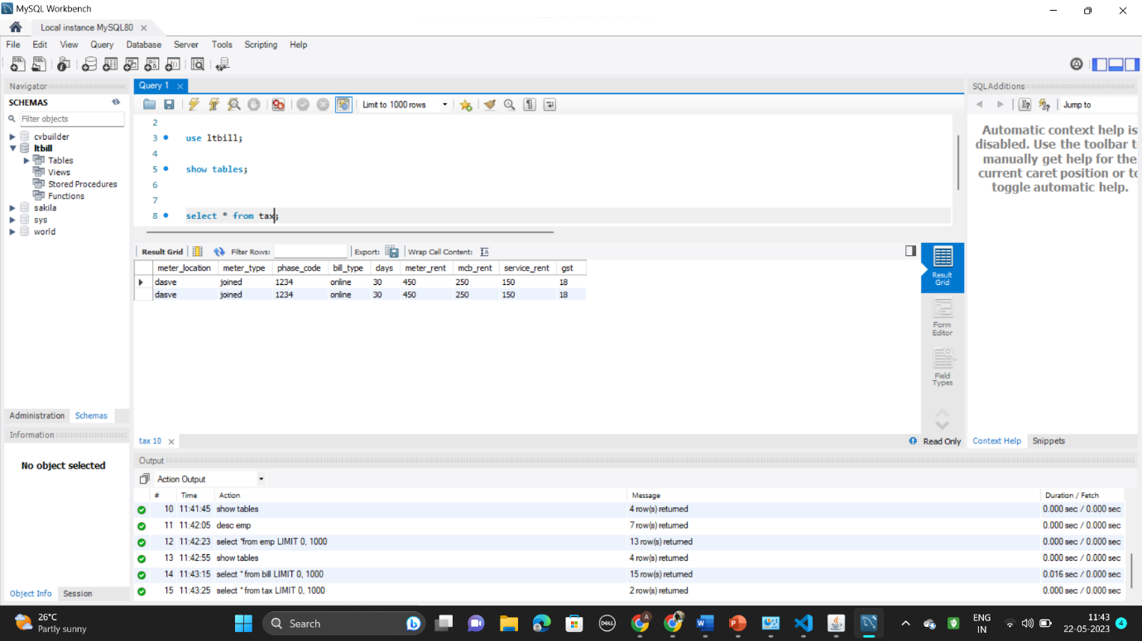

Java communicates with MySQL tables using JDBC which stands for Java Database Connectivity. This is how we have linked our tables to sql, for the proper working of our GUI based application.

Screenshots along with explanations about each step of our applications:

Login Page:

This is the login page for an employee to login and enter customer details so as to ease the payment of their electricity bills. The username and password is fixed and hence will show error if invalid password is typed.

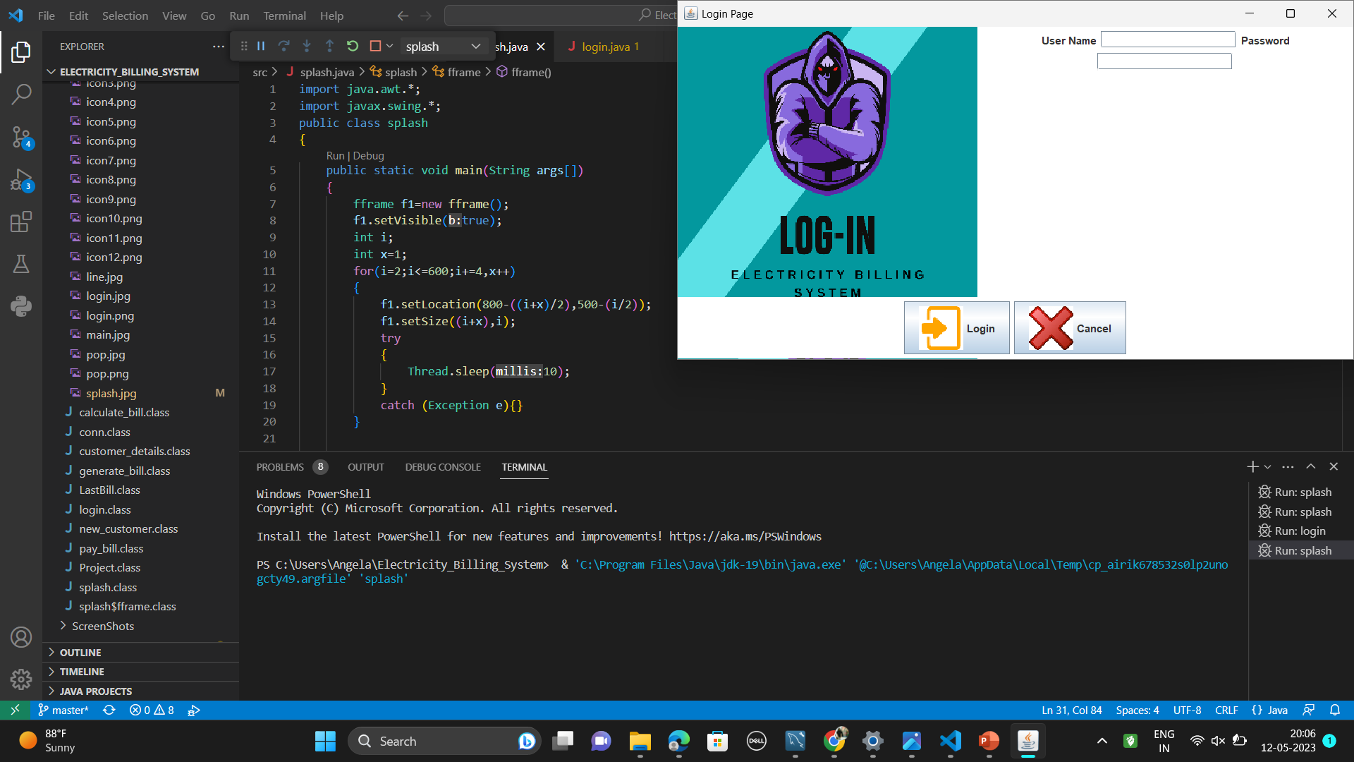

Main Page:

This is the main page after logging in. It displays the features which are present in the app, like adding customer, displaying customer details, calculating and generating bills etc.

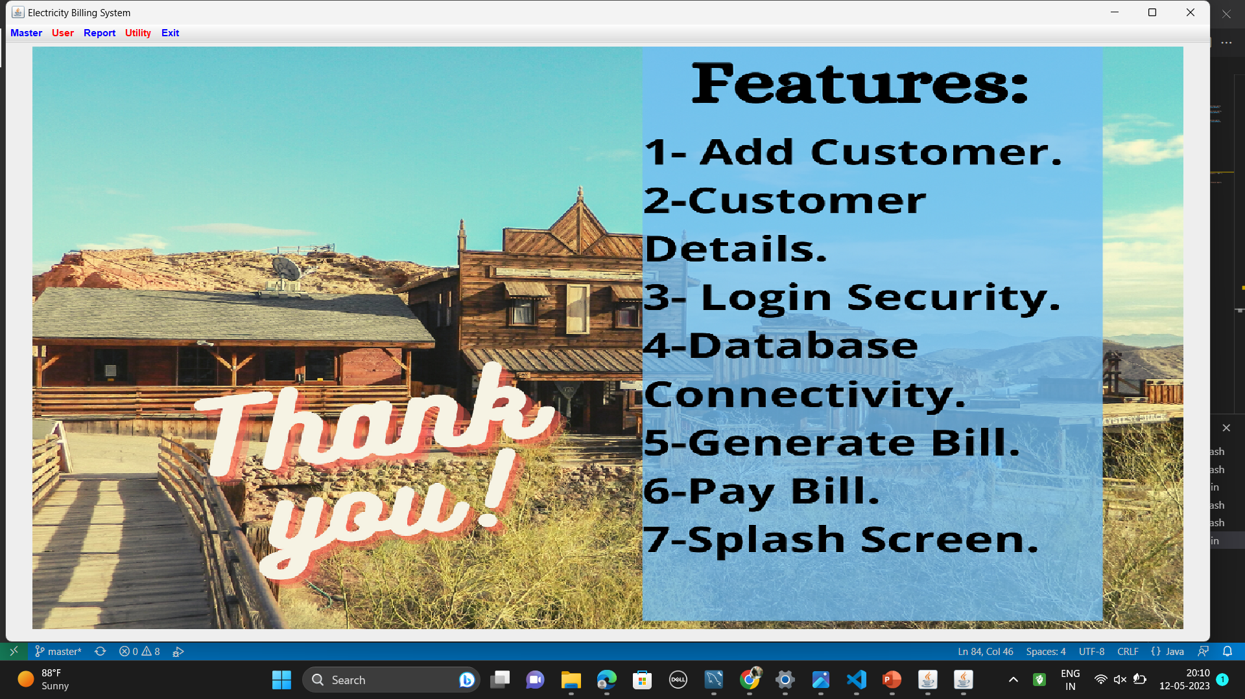

New Customer:

This the option for adding new customer to the database by entering certain details of the customer like name, meter number, address etc.

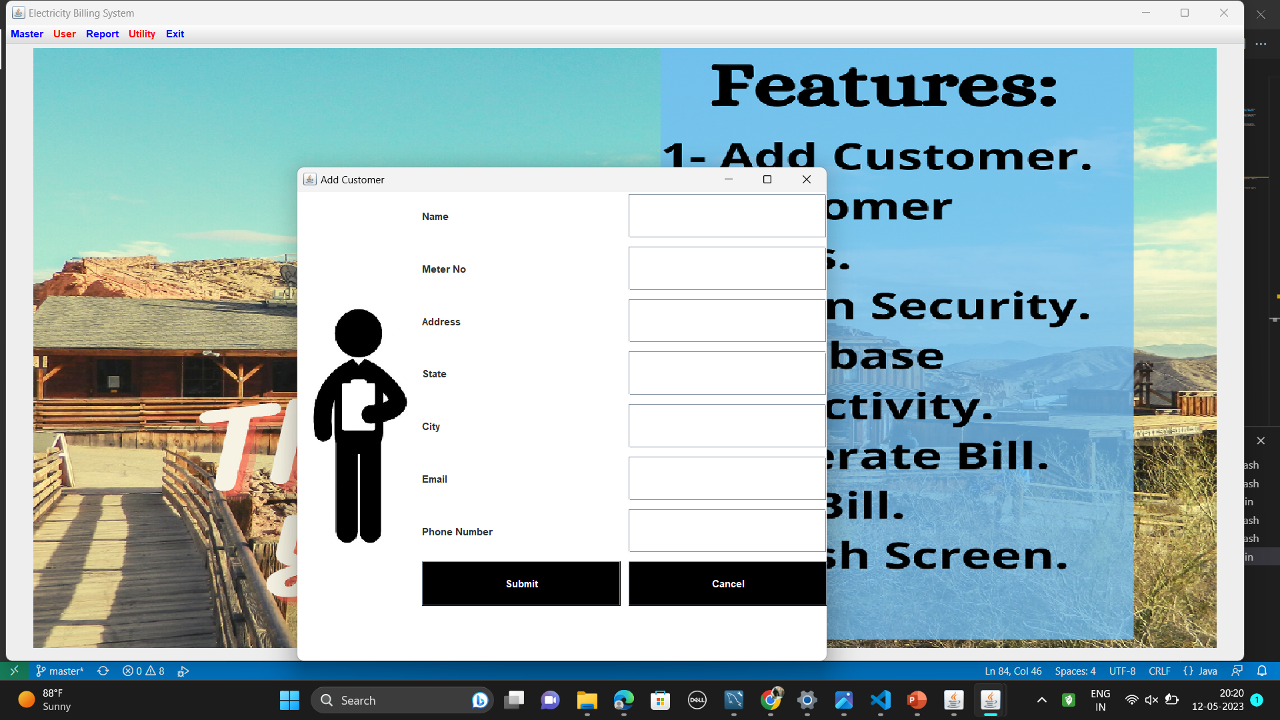

Customer Details:

This is to display the details of the existing customers entered by the employee.

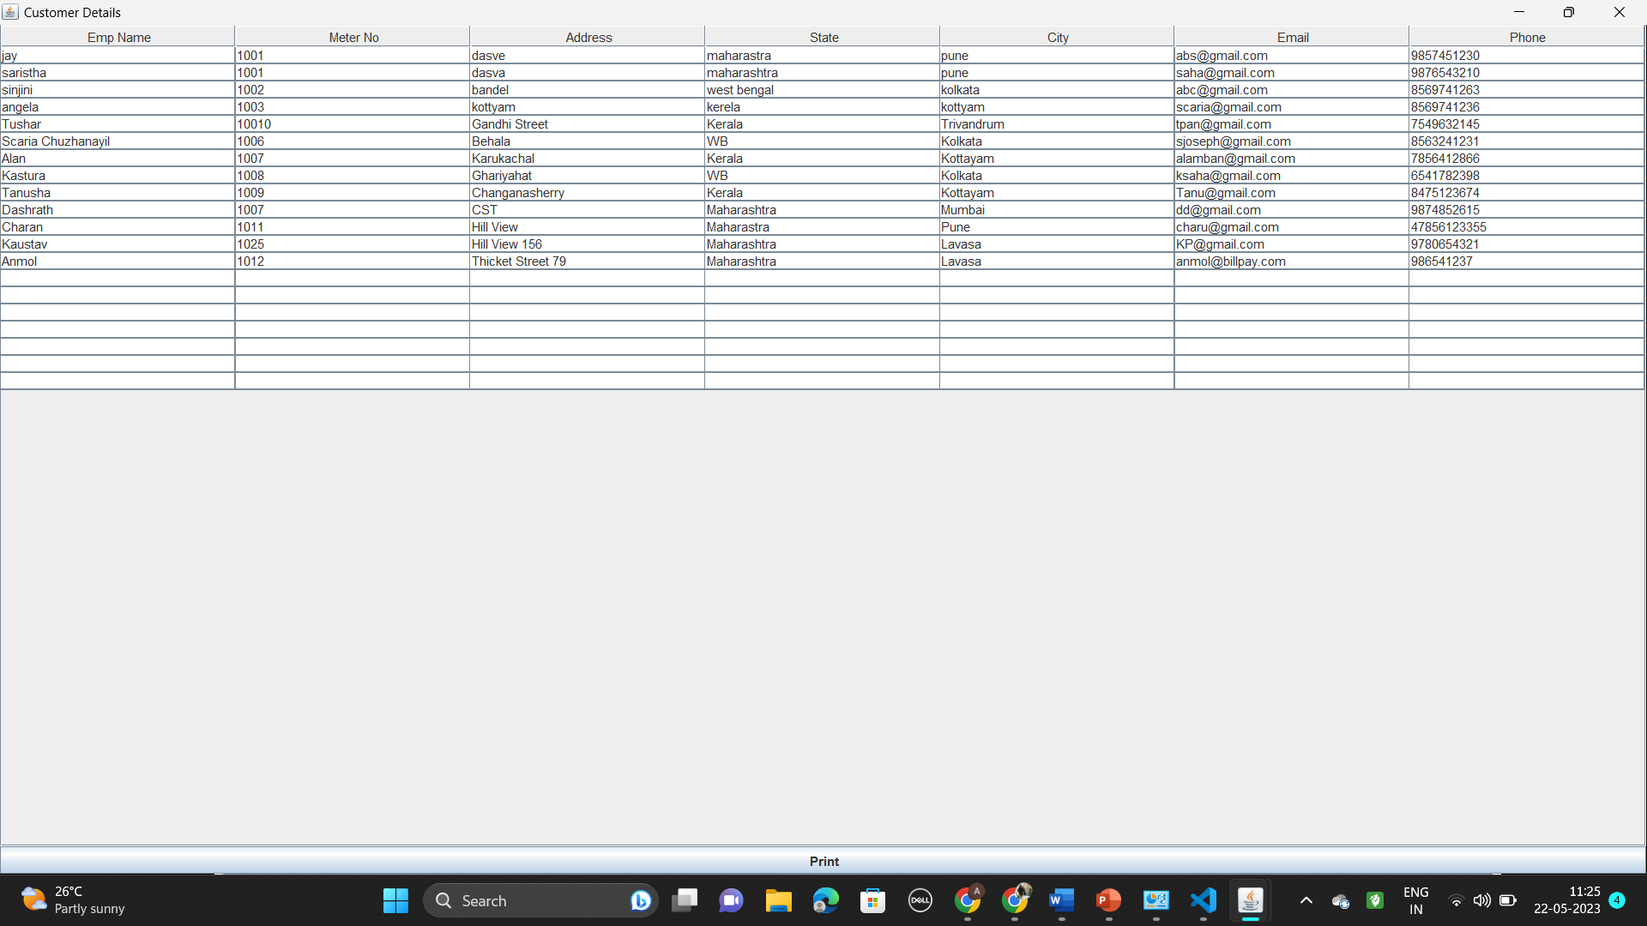

Calculate Electricity Bill:

This is to calculate the electricity bill of a particular customer using their meter no and month and units consumed.

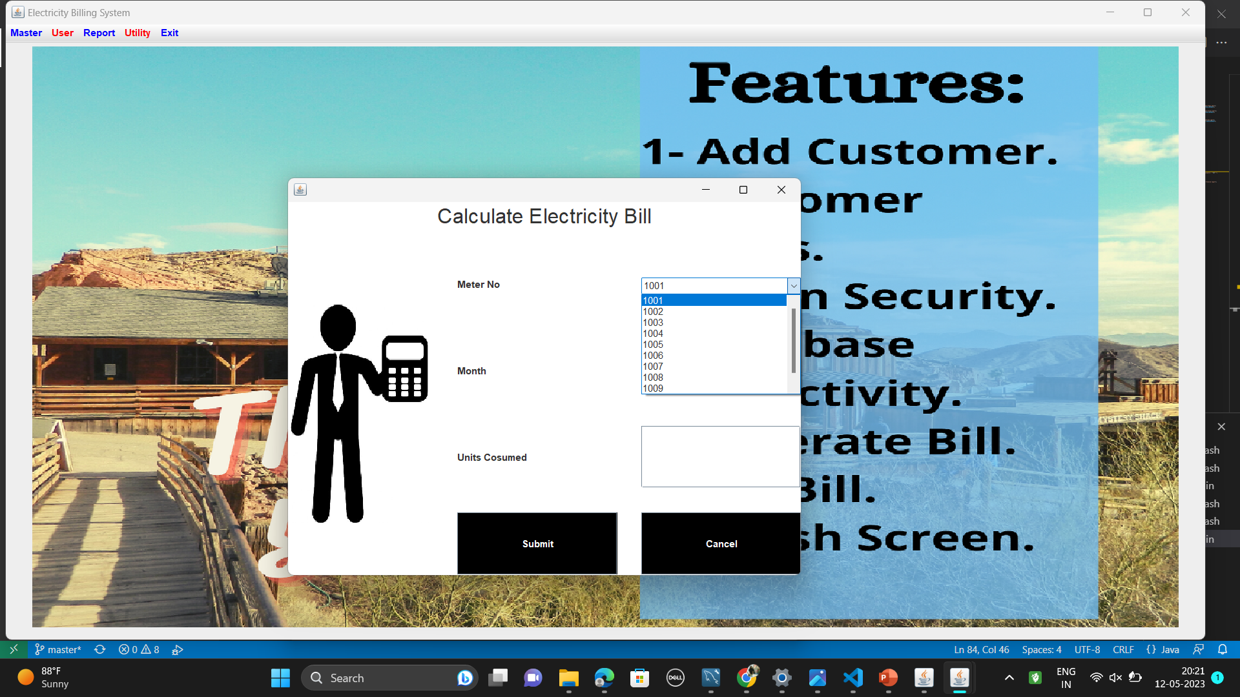

Generate Bill:

This page allows the user to generate the bill using month and meter number.

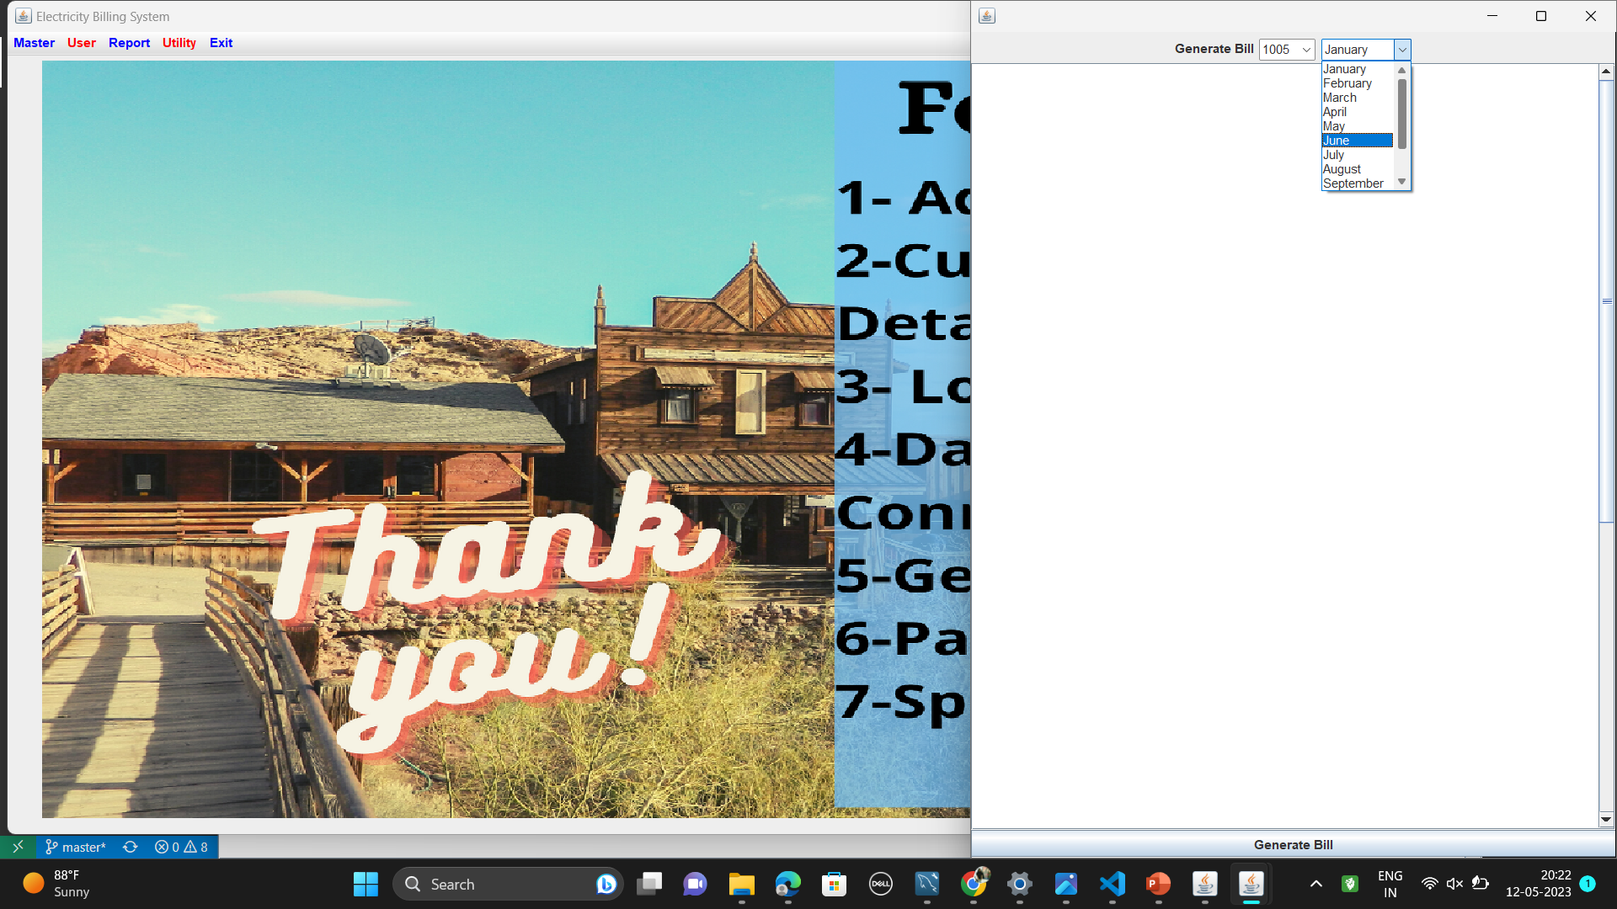

Bill Details:

This page shows the bill details after generation of the bills.

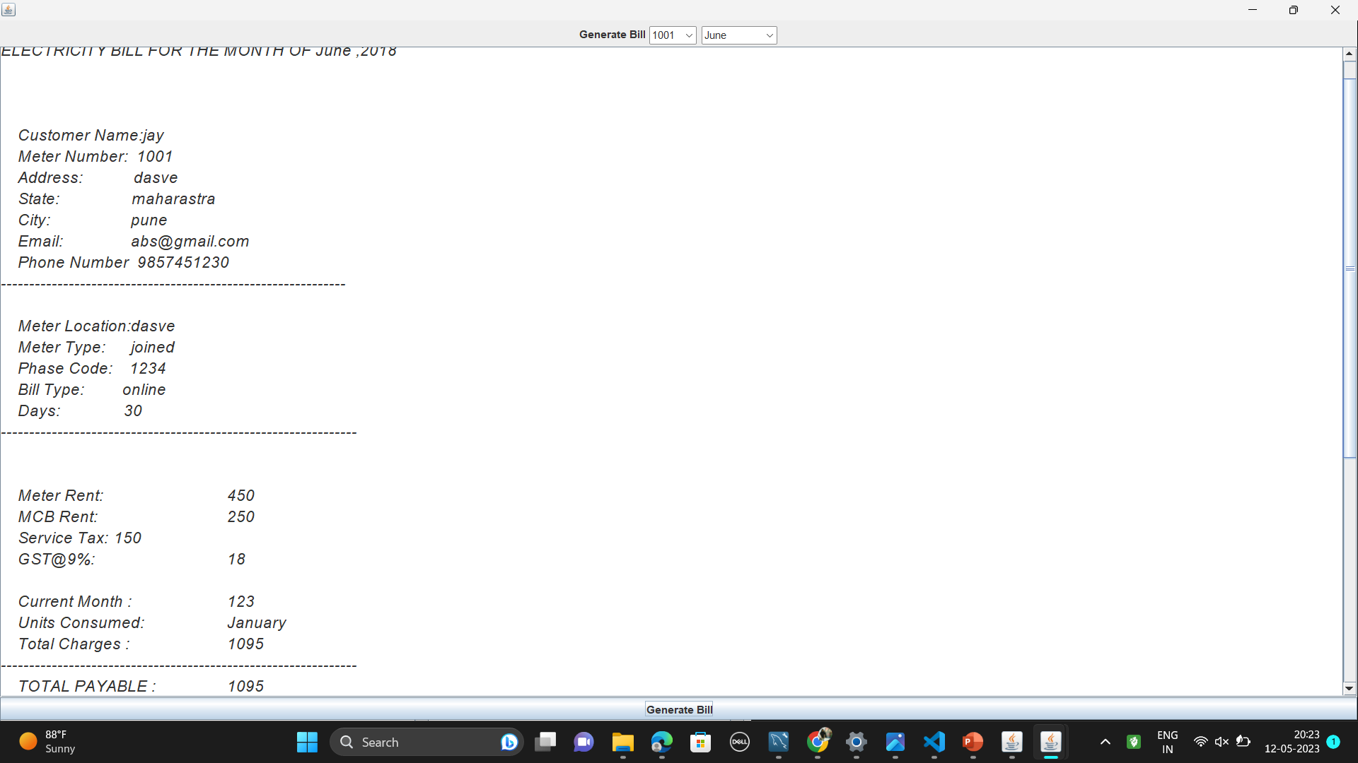

Payment Portal:

This is the page that leads to an online electricity bill payment portal for the bill to be paid directly through online mode.

